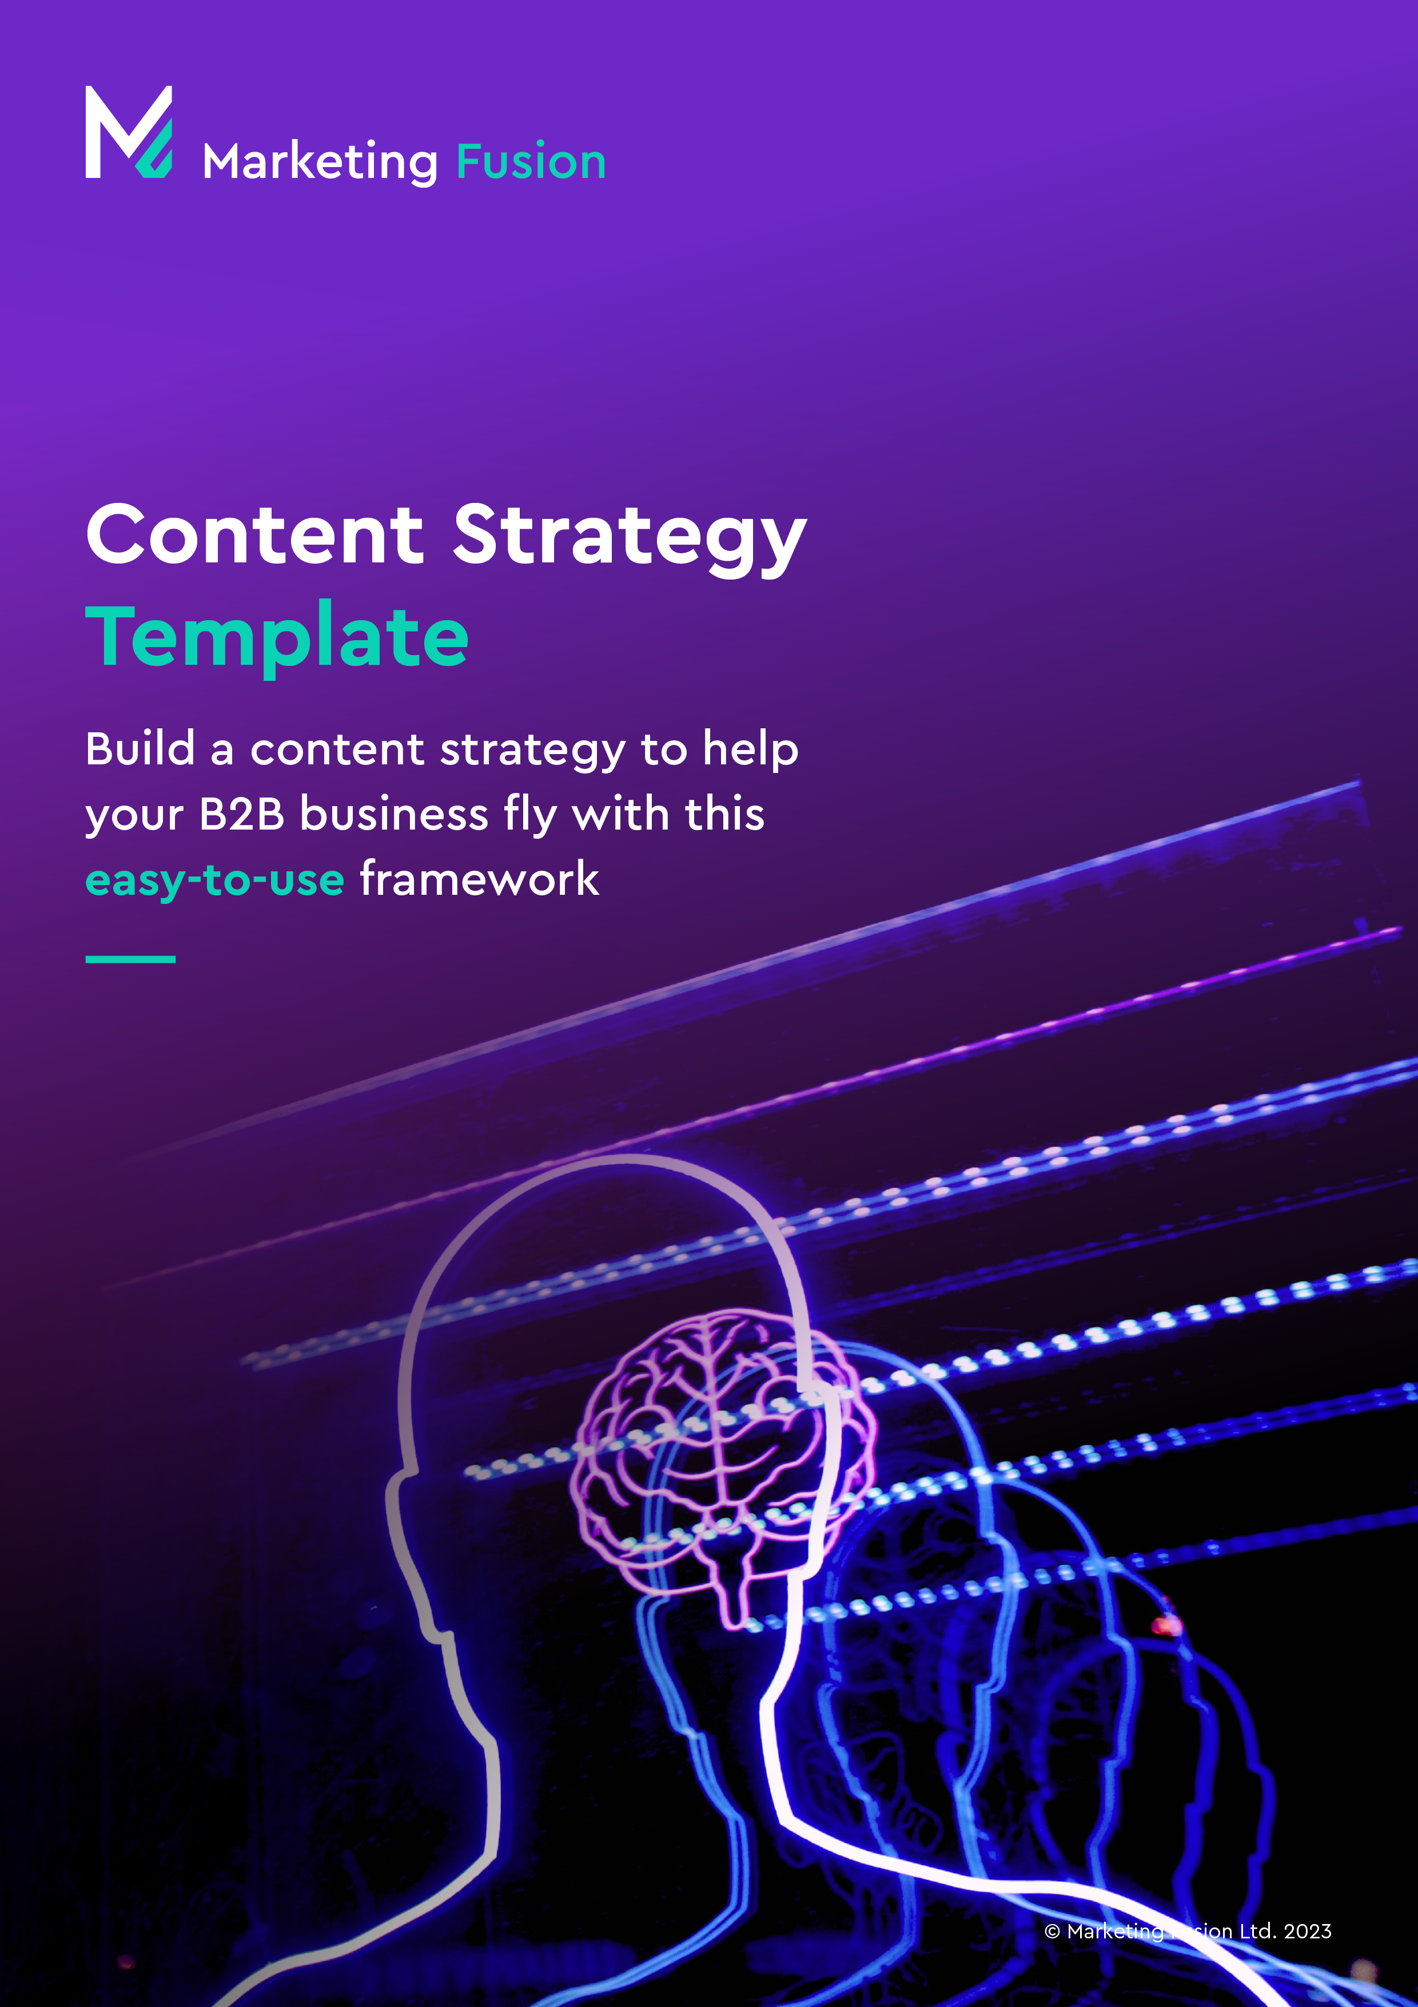

Great content starts here

A strong content strategy should be the cornerstone of any business  
communications programme. Miss out this vital step and you run the   
risk of confusing or alienating your prospects and customers.

Use our handy template below to structure your ideas, identify   
gaps and build a plan to **succeed with content.**

Step 1: Tell us your brand story?

|  |  |
| --- | --- |
| **Your brand** | **Why is it relevant?** |
| * How and why did your  business come into being? * How has it evolved? * What obstacles have  you overcome? * Who are the  people involved? * Do your leaders have  strong passionate beliefs? * Have they overcome  major obstacles? * Disrupted an  established market? | People buy from people. And  people love stories – they  stick in the mind.  As Steve Jobs, Simon Sinek and  others have said – the ‘why’ is often more important than ‘what’  you do.  So, think about the best way to  tell your story. But don’t forget that authenticity is important so don’t  try to be something you’re not. |
| **Tell us about your brand story** | |
| Share your story……………………………………………………………………….  ………………………..………………………..………………………..………… ……………..………………………..………………………..……………………….. ………………………..………………………..………………………..………………  ……………..………………………..………………………..……………………….. ………………………..………………………..………………………..……………… ………..………………………..………………………..……………………… ..………………………..……………………..…………………………  ……………..………………………..………………………..……………………….. ………………………..………………………..………………………..……………… ………..………………………..………………………..……………………… ..………………………..……………………..………………………… | |

Step 2: What are your brand values?

|  |  |
| --- | --- |
| **Your values** | **Why is it relevant?** |
| * What are your core values? * What adjectives best describe  you and the way you want  people to feel about your business? Try to pick  words that will help you to  stand out from the rest  of the pack. | These values need to underpin  every tweet, blog and ad, as  well as your longer form content.  They feed into the visuals and  words you choose to represent  you, as people form an impression  of you based on your content. |
| **Tell us about what your brand stands for** | |
| Share your values……………………………………………………………………….  ………………………..………………………..………………………..………… ……………..………………………..………………………..……………………….. ………………………..………………………..………………………..……………… ………..………………………..………………………..……………………… ..………………………..………………………………………………  ……………..………………………..………………………..……………………….. ………………………..………………………..………………………..……………… ………..………………………..………………………..……………………… ..………………………..……………………..…………………………  ……………..………………………..………………………..……………………….. ………………………..………………………..………………………..……………… ………..………………………..………………………..……………………… ..………………………..……………………..………………………… | |

Step 3: What is your brand expertise?

|  |  |
| --- | --- |
| **Your knowledge** | **Why is it relevant?** |
| * What are you and your team knowledgeable about? * What are the questions you  most commonly get asked? * How can you capture and  distil your expertise? | Content strategy is all about what  you know rather than what you sell  – and extends beyond the product.  People want to know how to solve  their problems and get answers  to their questions rather than receiving  a product pitch. |
| **Tell us about your knowledge and expertise** | |
| ………………..……………………………………………………………………….  ………………………..………………………..………………………..………… ……………..………………………..………………………..……………………….. ………………………..………………………..………………………..……………… ………..………………………..………………………..……………………… ..………………………..………………………………………………  ……………..………………………..………………………..……………………….. ………………………..………………………..………………………..……………… ………..………………………..………………………..……………………… ..………………………..……………………..…………………………  ……………..………………………..………………………..……………………….. ………………………..………………………..………………………..……………… ………..………………………..………………………..……………………… ..………………………..……………………..………………………… | |

Your Goals

Step 4: What are your brand goals?

|  |  |
| --- | --- |
| **Your business goals** | **Why is it relevant?** |
| * What are your goals  for the business? To grow?  By how much? By when? * Where do you see that coming from? Your existing products  and markets? New products? New markets? Or both? * Ideally your goals should be  Smart (Specific, Measurable,  Attainable, Relevant and Timely). | Be clear about what you want  to achieve so you can be sure that your content supports  those objectives.  If your business strategy is  to expand into new markets  or with new offerings,  you’ll need to adjust your  content goals accordingly. |
| **Tell us about the goals, aims and ambitions for your brand** | |
| ………………….……………………………………………………………………….  ………………………..………………………..………………………..………… ……………..………………………..………………………..……………………….. ………………………..………………………..………………………..……………… ………..………………………..………………………..……………………… ..………………………..………………………………………………  ……………..………………………..………………………..……………………….. ………………………..………………………..………………………..……………… ………..………………………..………………………..……………………… ..………………………..……………………..…………………………  ……………..………………………..………………………..……………………….. ………………………..………………………..………………………..……………… ………..………………………..………………………..……………………… ..………………………..……………………..………………………… | |

Step 5: What are your content goals?

|  |  |
| --- | --- |
| **Your content** | **Why is it relevant?** |
| * Why are you producing content? * How does this contribute to  the overall business success? * For example, content goals could be: * To establish our expertise amongst SMBs in the expense management space. * To become a leading resource  for business leaders in cyber  security risk management. | If it doesn’t contribute to the overall  goal, content for content’s sake  can be wasteful and confusing.  Don’t waste time producing endless  technical messaging if your target audience is business leaders. |
| **Tell us about the type of content you generate** | |
| ………………..……………………………………………………………………….  ………………………..………………………..………………………..………… ……………..………………………..………………………..……………………….. ………………………..………………………..………………………..……………… ………..………………………..………………………..……………………… ..………………………..………………………………………………  ……………..………………………..………………………..……………………….. ………………………..………………………..………………………..……………… ………..………………………..………………………..……………………… ..………………………..……………………..…………………………  ……………..………………………..………………………..……………………….. ………………………..………………………..………………………..……………… ………..………………………..………………………..……………………… ..………………………..……………………..………………………… | |

Your Audience

Step 6: Tell us about your brand’s audience?

|  |  |
| --- | --- |
| **Your audience** | **Why is it relevant?** |
| * Which organisations are  you looking to target? * What size, location, industry  sector or other qualifying  criteria do they have to meet? * Do you want to focus  on Enterprise or SMB?  Finance or Manufacturing?  UK, US or global? | Although content targets the  individual; their environment,  challenges, interests and focus  are largely affected by the  organisation they are part of. |
| **Tell us about your audiences needs and wants** | |
| ………………………………………………………………………………………….  ………………………..………………………..………………………..………… ……………..………………………..………………………..……………………….. ………………………..………………………..………………………..……………… ………..………………………..………………………..……………………… ..………………………..………………………………………………  ……………..………………………..………………………..……………………….. ………………………..………………………..………………………..……………… ………..………………………..………………………..……………………… ..………………………..……………………..…………………………  ……………..………………………..………………………..……………………….. ………………………..………………………..………………………..……………… ………..………………………..………………………..……………………… ..………………………..……………………..………………………… | |

Step 7: What is/are your target persona(s)?

|  |  |
| --- | --- |
| **Your target** | **Why is it relevant?** |
| * Who are the individuals  you want to reach? * Who are the decision  makers, the influencers? * What challenges and pains  do they face that you can address? * What do their daily lives look like? * What are their external influences? | The more personalised the better, so being laser focused  in your content is vital.  In B2B there’s likely to be a  decision-making team. If the  business users drive the need  but IT are the gate keepers,  you’ll need to create content  to address both. |
| **Tell us about your brand personas** | |
| ………………………………………………………………………………………….  ………………………..………………………..………………………..………… ……………..………………………..………………………..……………………….. ………………………..………………………..………………………..……………… ………..………………………..………………………..……………………… ..………………………..………………………………………………  ……………..………………………..………………………..……………………….. ………………………..………………………..………………………..……………… ………..………………………..………………………..……………………… ..………………………..……………………..…………………………  ……………..………………………..………………………..……………………….. ………………………..………………………..………………………..……………… ………..………………………..………………………..……………………… ..………………………..……………………..………………………… | |

Step 8: What’s your customer journey?

|  |  |
| --- | --- |
| **Their journey** | **Why is it relevant?** |
| * What does the buyer  journey look like for your  prospective customers? * Where do they search  for information? * What influences them? * What types of information  do they typically consume? | Your content should be relevant  for your prospective buyer at  each stage of their journey, so  understanding that journey will  help you tailor content appropriately.  At the early stages, you’ll need to  grab their attention, then provide  deeper content to explain and convert. |
| **Tell us about your customers journey** | |
| ………………….……………………………………………………………………….  ………………………..………………………..………………………..………… ……………..………………………..………………………..……………………….. ………………………..………………………..………………………..……………… ………..………………………..………………………..……………………… ..………………………..………………………………………………  ……………..………………………..………………………..……………………….. ………………………..………………………..………………………..……………… ………..………………………..………………………..……………………… ..………………………..……………………..…………………………  ……………..………………………..………………………..……………………….. ………………………..………………………..………………………..……………… ………..………………………..………………………..……………………… ..………………………..……………………..………………………… | |

Your Content

Step 9: What are your content topics?

|  |  |
| --- | --- |
| **Topics and themes** | **Why is it relevant?** |
| * Based on your target audience,  their pain points, your expertise  and the market environment - identify core themes. * These may be new or existing  themes that you already have  content for, that you can  revisit or repurpose. * Review how your existing  content has worked, not just  in terms of likes and clicks  but what’s generated the  most pipeline and business. | Your content needs to address a real pain point for your audience.  Carry out keyword research  to identify what search terms  are ranking.  However, keywords can be  subjective and if you’re in a niche  market may not register at all.  If in doubt – ask your customers  what their priorities and concerns  are in the years and months ahead. |
| **Tell us about your content style** | |
| ………………………………………………………………………………………….  ………………………..………………………..………………………..………… ……………..………………………..………………………..……………………….. ………………………..………………………..………………………..……………… ………..………………………..………………………..……………………… ..………………………..………………………………………………  ……………..………………………..………………………..……………………….. ………………………..………………………..………………………..……………… ………..………………………..………………………..……………………… ..………………………..……………………..…………………………  ……………..………………………..………………………..……………………….. ………………………..………………………..………………………..……………… ………..………………………..………………………..……………………… ..………………………..……………………..………………………… | |

Step 10: What is your campaign structure?

|  |  |
| --- | --- |
| **Your campaigns** | **Why is it relevant?** |
| * For each theme plan  to create a core ‘offer’. * This is your ‘pillar content’  that will provide the greatest  ‘pull’ value for conversion. * In addition, identify the longer tail search terms  that maybe used for more  specialised searches. | These will become the topics/titles  for shorter form content like blogs, infographics and social media,  offering links to the pillar content,  and creating strong internal  referencing, to establish authority  with Google on the chosen theme. |
| **Tell us about your campaign process and planning** | |
| ………………….……………………………………………………………………….  ………………………..………………………..………………………..………… ……………..………………………..………………………..……………………….. ………………………..………………………..………………………..……………… ………..………………………..………………………..……………………… ..………………………..………………………………………………  ……………..………………………..………………………..……………………….. ………………………..………………………..………………………..……………… ………..………………………..………………………..……………………… ..………………………..……………………..…………………………  ……………..………………………..………………………..……………………….. ………………………..………………………..………………………..……………… ………..………………………..………………………..……………………… ..………………………..……………………..………………………… | |

Step 11: Do you have a content calendar?

|  |  |
| --- | --- |
| **Your schedule** | **Why is it relevant?** |
| * Schedule your content themes  and assets for the year,  at a high level at least. * Your content themes should vary but even if your list is infinite,  a weekly changing content  theme is likely be too much  in the B2B world. * In our experience, a quarterly  theme tends to work best  – but may not be right for  every business/industry  or target audience. | Having a visible content  calendar allows you to plan  ahead and co-ordinate content  with other marketing activities like  events and external publications. |
| **Tell us about your content schedule** | |
| ………………………………………………………………………………………….  ………………………..………………………..………………………..………… ……………..………………………..………………………..……………………….. ………………………..………………………..………………………..……………… ………..………………………..………………………..……………………… ..………………………..………………………………………………  ……………..………………………..………………………..……………………….. ………………………..………………………..………………………..……………… ………..………………………..………………………..……………………… ..………………………..……………………..…………………………  ……………..………………………..………………………..……………………….. ………………………..………………………..………………………..……………… ………..………………………..………………………..……………………… ..………………………..……………………..………………………… | |

Step 12: Who’s responsible for your content?

|  |  |
| --- | --- |
| **Your team** | **Why is it relevant?** |
| * Who is responsible for developing/ writing new content? * Do you have the resources in-house  or will you need external suppliers? * Who will need to provide input? * Who is responsible for sign off/publication? | Get everyone on board including  product management/subject matter experts, marketing communications,  web teams and anyone who is likely to  be involved in the process.  Getting their buy in and support  makes things a whole lot easier  down track when you need their  valuable time. |
| **Tell us about your content schedule** | |
| ………………………………………………………………………………………….  ………………………..………………………..………………………..………… ……………..………………………..………………………..……………………….. ………………………..………………………..………………………..……………… ………..………………………..………………………..……………………… ..………………………..………………………………………………  ……………..………………………..………………………..……………………….. ………………………..………………………..…………………..……………… ………..………………………..………………………..……………………… ..………………………..……………………..…………………………  ……………..………………………..………………………..……………………….. ………………………..………………………..………………………..……………… ………..………………………..………………………..……………………… ..………………………..……………………..………………………… | |

The Market

Step 13: What’s your market?

|  |  |
| --- | --- |
| **Your market** | **Why is it relevant?** |
| * How are external factors  impacting your business  and in particular your  customer’s business. * How has technology changed? * Any legal deadlines or  market dynamics like GDPR  or Brexit that have happened  or are looming? | If there’s an issue that’s  capturing attention and focus  – how can you take advantage?  How can you help your  customers leverage emerging  tech, new channels or changing  customer behaviour? |
| **How has the market changed your business?** | |
| ………………….……………………………………………………………………….  ………………………..………………………..………………………..………… ……………..………………………..………………………..……………………….. ………………………..………………………..………………………..……………… ………..………………………..………………………..……………………… ..………………………..………………………………………………  ……………..………………………..………………………..……………………….. ………………………..………………………..………………………..……………… ………..………………………..………………………..……………………… ..………………………..……………………..…………………………  ……………..………………………..………………………..……………………….. ………………………..………………………..………………………..……………… ………..………………………..………………………..……………………… ..………………………..……………………..………………………… | |

Step 14: How are you measuring your impact?

|  |  |
| --- | --- |
| **Your data** | **Why is it relevant?** |
| * All this great planning  and execution could be  meaningless unless you  measure what’s working  and what isn’t. * Discover insights to determine  where to go next by monitoring  key metrics such as brand  awareness, engagement and  lead generation. * And don’t forget to document  and report on progress for  future planning. | Tracking data for the sake  of tracking data isn’t a valuable  use of your time, but if you  can derive actionable insights from your metrics and adjust  how you create content as a  result, you’ll be in a much  better position to drive results  for your company and team. |
| **How does your business currently track data?** | |
| …………………..……………………………………………………………………….  ………………………..………………………..………………………..………… ……………..………………………..………………………..……………………….. ………………………..………………………..………………………..……………… ………..………………………..………………………..……………………… ..………………………..………………………………………………  ……………..………………………..………………………..……………………….. ………………………..………………………..………………………..……………… ………..………………………..………………………..……………………… ..………………………..……………………..…………………………  ……………..………………………..………………………..……………………….. ………………………..………………………..………………………..……………… ………..………………………..………………………..……………………… ..………………………..……………………..………………………… | |

Thank you for   
taking the time  
to share your   
story with us

This questionnaire is a great tool   
and reference point for our team,   
in help us to **tailor the content**   
we create for your business.

Disclaimer:

Marketing Fusion puts the security of their clients   
at a high priority. Therefore, we have put efforts   
into ensuring that any information shared in   
this questionnaire is strictly confidential.